IMPLEMENTATION GUIDE

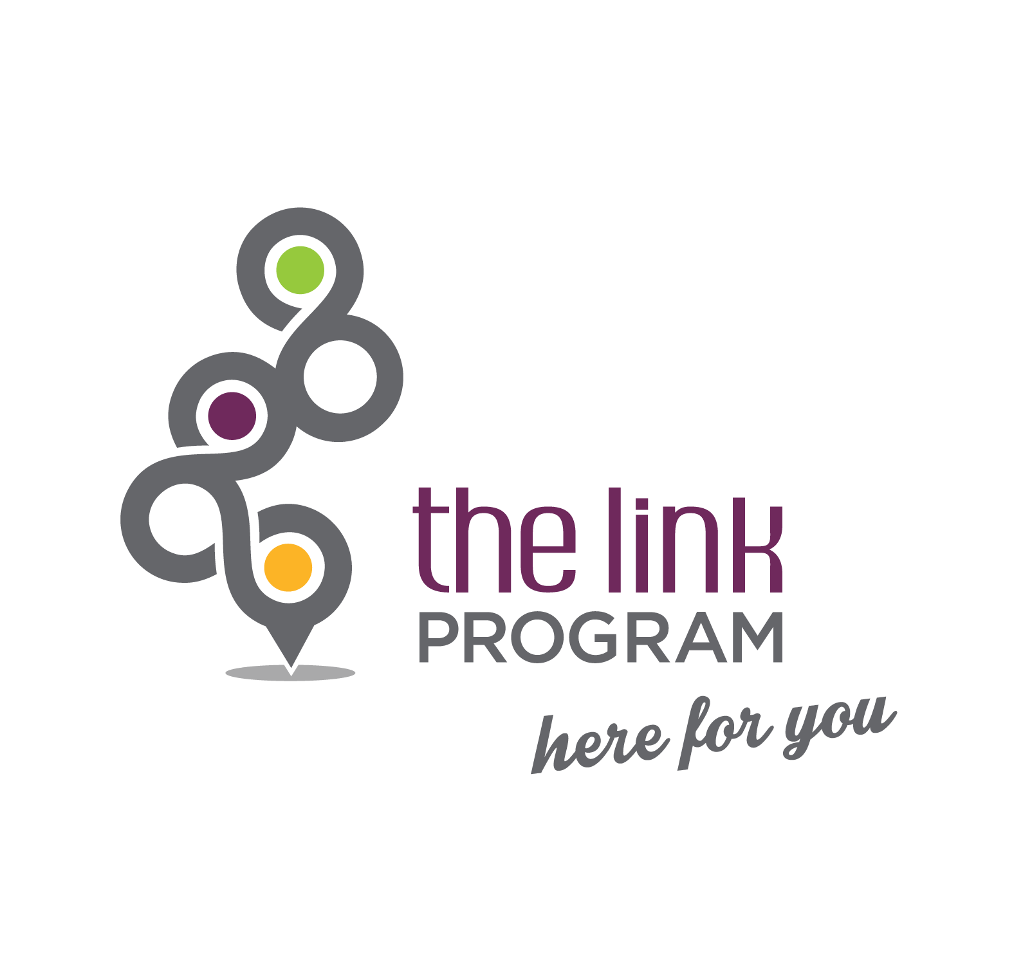

2016
Table of Contents

Foreword …………………………………….…………………………………………. 5

Part 1: History…………………………………………………….………………. 5

1.1 In New Brunswick …………..…………………………….…………………........ 5

Part 2: Description of Program ………….………………........................ 6

2.1 Goal ……..………………………………………………………………………….. 6
2.2 Meaning of Link symbol …….……………………………………………………. 6
2.3 Target Clientele…………..…………………………………………..……………. 6
2.4 Benefits…………………………………………………………………………..…. 7
2.5 Funding………….………………………………………………………………….. 8

Part 3: Operations/Materiel……..………........................................................ 8

3.1 Posters and Banners………………………………………..……………………… 9
3.2 Companion Stickers……………………………………………………………… 9
3.3 Link Card……………………………………………………………..……………… 10
3.4 Helping Tree………………………………………………...…………..………… 11
3.5 Glossary …………………………………………………………………………….. 12
3.6 Other Material (web page, promotional tools) ………………………….…….…. 13

Part 4: Roles………………………………………………………….………………... 13

4.1 Companions…………………………………….……………………….…………… 13
4.2 school coordinators…………………………………………….…………………. 15

Part 5: Steps in the Implementation Process………………………….. 15

5.1 Consultation with Those Responsible for the Link Program……….………...… 15
5.2 The regional Link Committee….…………….…………………..….….…….……. 16
5.2.1 Role and responsibilities of regional committees ..……………………….. 17
5.2.2 Regional committee lead..…………………………………………………... 18
5.3 Preparation of the Link material………………………………………………… 18
5.4 Promotion of program in host setting…………………………………………… 18
5.5 Training of future companions ………………………..…………………..….. 19
5.6 Launch of the program in the host setting…………….………………..……….. 20

5.7 Ensuring implementation of the Link program in the target setting …………. . 20
5.8 Getting the approval of school principals ……………………………………..… 20
5.9 Construction of Helping Tree…………………………..….….……………….….. 20
5.10 Validation of partner organizations……………….….…………………………… 21
5.11 Host Setting Awareness………………...……………………………...…………. 21
5.12 Printing of promotional material………………….……………………….……… 21
5.13 Launch of program in schools………..…………………………….…………….. 22
5.14 Public launch……………………………………………….…………….……….... 23

Part 6: Implementation …………………………………………………………….. 24

6.1 Coordinator/Companion ………………………………..…..……….……….…… 25

Part 7: Conditions for Success ……………………………………………….…25

7.1 Aspects relating to the persons implementing the Program…………………....…. 26
7.1.1 Positive impact on the organization as a whole………………………….... 26
7.1.2 Simple structure ………………………………………………………...……. 26

7.1.3 Involving the right people (regional committee)…...………………………. 26
7.1.4 Getting the support of the partners’ executive directors ……..………... 26

7.1.5 Using a collaborative structure…………………….……………..…..…….. 27

7.1.6 Validating the organizations included in the Helping Tree….………….. 27

7.2 School-related Aspects (host setting) …………………………………….……..… 27
7.2.1 Getting the support of the school district superintendents……….………. 27
7.2.2 Mobilizing the administration………………………………………………… 28
7.2.3 Promoting the voluntary involvement of companions………………..…… 28
7.2.4 Informing all stakeholders (parents, unions, boards, etc.)……....……….. 28
7.2.5 Motivating the team..…………………………………………………….…… 28
7.2.6 Providing training…………………………………………………..………….. 29

Conclusion ……………………………………………………………….…………..…. 29

Appendix 1: Training for Companions

Foreword
This guide was prepared to provide interested parties with tools for implementing the Link Program and to facilitate and optimize success at each stage of the implementation process. It will also be of interest to anyone who works with young people and wants to be able to refer them to the appropriate resources.
It is hoped that the guidelines in this document will be useful to individuals in a given setting and will make the implementation process easier. However, most of the information provided can and should be adapted to local circumstances.

Part 1: History

In New Brunswick
The Link Program was first developed in a small New Brunswick community. Following the tragic deaths of three teenagers in the Grand Falls region in the mid-1990s, two of which were confirmed suicides, the Grand Falls Suicide Prevention Committee and a group of school principals and school and health professionals started exploring ways of helping young people find solutions to their issues with the assistance of a resource person and thus become more resilient. They were supported in their efforts by the Club Richelieu de Grand-Sault. That collaboration led to the development of the Link Program in 1999. Since then, the program, aimed at students in Grades 6 to 12, has been implemented in many New Brunswick schools. The program was expanded thanks to Live Well, Be Well, the provincial wellness strategy of the Department of Healthy and Inclusive Communities. This strategy provides a large amount of the funding for the Link Program, includes the services of a provincial coordinator, and makes provision for the program to be expanded to all provincial schools with students in Grades 6 to 12. In addition, the Link Program was included in When Kids Come First, the action plan of the Department of Education. Other provinces in Canada have followed New Brunswick’s lead and implemented the program as well.
The Link Program was launched at the provincial level in New Brunswick in 2006 and now has 14 regional Link committees.

Since its establishment, the Link Program has twice won the Provincial Prize of Excellence in Suicide Prevention. In October 2002, the award went to the Grand Falls Link Program Committee for its suicide prevention efforts, and in September 2006, it went to the Madawaska Link Program Committee for greatest growth.

Part 2: Description of Program

Goal

With the support of a LINK COMPANION or of a trusted person, the Link Program provides students with an opportunity to talk about their concerns and, if needed, to access support services in the community using the HELPING TREE. By facilitating access to support services, the Link program wants to give students the opportunity to address their issues before they escalate and lead to more serious situations. The program is available in grade 6th to 12th schools.

2.2 Meaning of the Link symbol
The rounded shapes symbolize collaboration and flexibility. The grey symbolizes trust, the green, hope, the yellow, prevention and the burgundy, prudence. The links connected to one another represent the interrelation between individuals living in the same environment. It also represents the “Helping Tree”. Each link is of equal importance. If one is broken or defective, the whole chain is affected and cannot suitably play its role. On the other hand, if all links are solid, so is the whole chain.

All the links are connected, as are members of the community. When we all work together and communicate openly, the chain becomes stronger and the tree grows strong and healthy.

2.3 Target Clientele
First and foremost, the Link Program is geared towards Grades 6 to 12 students. However, over the years, the program has been expanded to include other target groups. Some regional committees have opted to implement the program in post-secondary education, workplace, and community settings. The age of the target population may therefore vary from region to region, depending on what the regional committee has decided. That said, it should be noted that the financial contribution of the Department of Healthy and Inclusive Communities is limited to costs incurred for students in Grades 6 to 12.

The number of institutions targeted for eventual implementation of the Link Program can vary from one regional committee to the next. For instance, a committee might decide to start with a single school and then draw up a schedule for implementing the program in other schools.

2.4 Benefits
Education – prevention and wellness promotion
Making people aware of the helping resources available in the community enables them to be better equipped to take up life’s challenges.
Support
Having a Link companion as a helper facilitates access to someone who can step in immediately and assist individuals who need help. The helping relationship with each individual becomes an important element that is valued by the Link Program.
Suicide prevention – promotion of life, resilience, and strategies
Holding an annual activity with our respective groups helps people come up with positive strategies for solving their issues before they get worse. That way, every individual adds resilience options for coping with life’s adversity more effectively.
Development of a culture
Getting people to realize they are all important links in the chain helps develop:
- a culture of mutual help;
- an environment sensitive to the distress of others;
- an openness to the importance of asking for help when you’re going through a difficult time.
By implementing the Link Program, we:
- encourage people to like themselves and to enjoy life;
- help people find constructive solutions;
- are able to prevent potentially destructive behaviours.
2.5 Funding
Through the Link executive committee, the Department of Social provides an annual $3,000 grant for each of the 14 regional Link committees. The initial contribution for implementing the program in a given region is $5,000. It is to be used exclusively to purchase promotional material for students in Grades 6 to 12. Priority must be given to purchasing the basic promotional materials (student cards, banner, posters, stickers and the Helping Tree), after which regional committees may purchase other promotional materials, if they have any money left over (pins, pencils, bracelets, t-shirts, memory sticks, mugs, etc.). Regional committees are responsible for finding other sources of funding to cover program-related costs not covered by the annual $3,000 contribution provided by the Department of Social Development.

Part 3: Operations/Material
To maintain the program’s reliability and validity, it is important to follow the steps in the procedure strictly. In order to comply with the copyrights for the promotional material and tools developed for the Link Program, all visual aspects of the program must be preserved (designs, colors, logo, slogan, graphic design, etc.).

- Posters and Banners
Posters (Image 1) and a banner (image not available) are used to publicize the program in the host setting (school hallway, cafeteria, etc.) and to let people know about the Link companions. The locations where the posters are displayed must be carefully thought out to optimize access to information.

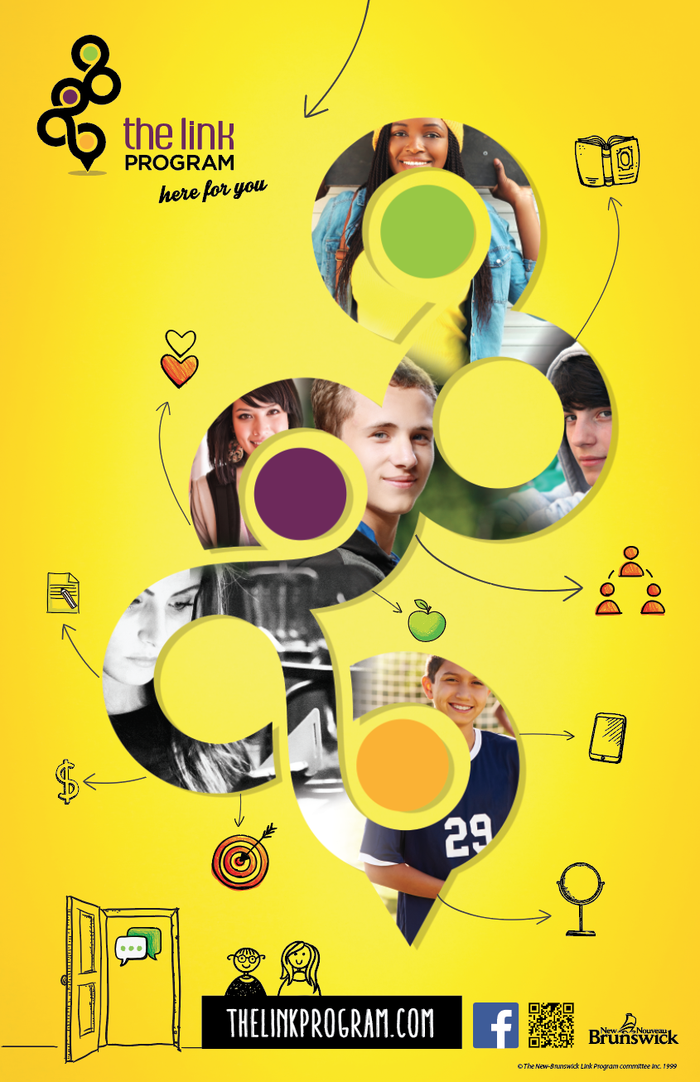
Image 1. Poster

- Companion stickers
In order to be easily identifiable, individuals who agree to participate in the program as companions place a Link sticker in a visible location (classroom or office door, window, binder, etc.).


Image 2 - Sticker
- Link Card
Another major component of the Link Program is the Link card (Image 3) handed out to all students. It is used as a communication tool between students and companions. These cards must therefore be available in large quantities. They should be distributed carefully as they will have an immediate impact on the students’ impression of the program and how they receive it. It is therefore important to hold a contact activity for the students to ensure greater mobilization and to lessen the chances that the cards will end up in the garbage. This will be looked at in more detail in the section on launching the program. The Link card provides toll-free telephone numbers for various resources. It serves as a communication tool between students and companions. It means “I want to talk to you,” “I need your help,” or “I've got an issue.”

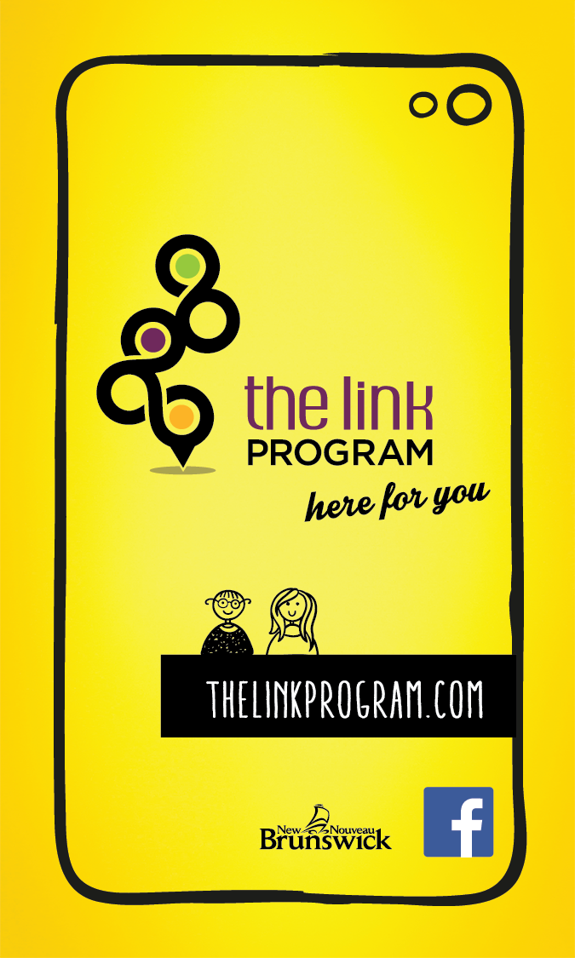
Image 3a: Card (front) Image 3b: Card (back)

- To make contact, students present their card to a companion or place it in a strategic location where the companion can find it (in the teacher’s mailbox, in homework, etc.).
- When a companion receives a yellow card, he or she contacts the young person to schedule a meeting.
- At that meeting, the companion helps the student identify the issue and, if need be, directs the student to a service that may meet his or her needs.

- Helping Tree

To help the companion direct the student, the Helping Tree (Image 4) is used to clarify the issue and, if needed, identify the various resources available. The resources listed in the Helping Tree may vary from region to region, and the regional committee has to decide which ones to include in the tree. Here is a list of the main issues generally included in the tree: Physical health and nutrition / Addiction (alcohol, drugs, medications, tobacco, gambling) / Grief / Academic issues / Financial and employment issues / Housing issues / Religion – Spirituality / Support for young parents / Social isolation / Suicidal thoughts, Mental health issues / Broken heart, peer pressure, blended families, separation, divorce / Eating disorders / Anger management and self-affirmation / Sexual health and pregnancy / Sexual orientation / Abuse (physical, emotional or sexual), neglect, family violence / Threats, harassment, intimidation, bullying, date violence / Legal issues / Social reintegration.
It should be noted that each of the 14 regions must prepare its own Helping Tree.

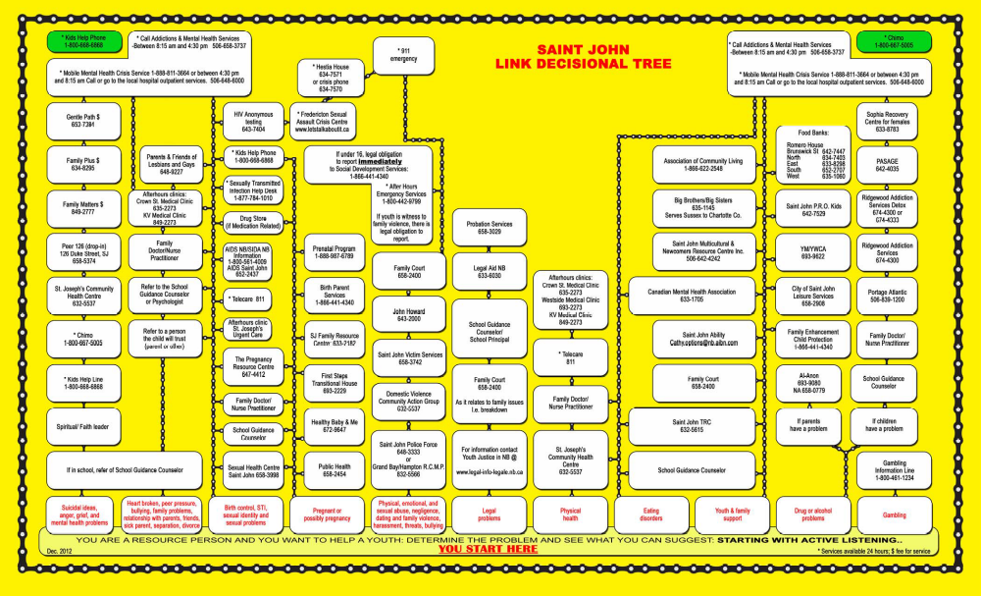
Image 4a: Helping Tree (inside)

Nb: The Helping Tree is inserted into an information pamphlet.

- Glossary (optional)

Having a glossary to go along with the Helping Tree is definitely beneficial and will be very useful for companions. A glossary enables them to refer to a tool that provides descriptions of the organizations included in the Helping Tree that may be helpful to young people. It also gives the name, telephone number, email address, and website address of the organization, along with a description of the services offered. The mission, hours of operation, and people in charge of the organization could be included as well. Since certain resources and their services are not as well known, having a glossary enhances the content of the Helping Tree and enables companions who meet with young people to serve them better by referring them to the organization that, in their view, can best meet their needs.
Regional committees that decide to prepare a glossary must determine who will be in charge of that. They are also responsible for defining the glossary’s content, format, and layout. It should be remembered that this tool must be updated periodically.

- Other Material
Web page
The program’s website is another effective way of raising awareness of the program. The regional committees are asked to forward any information they want uploaded to the website to the provincial coordinator: http://programmelemaillon.com

Other promotional tools
Other promotional tools could include pins, pencils, bracelets, memory sticks, mugs, etc…. It is up to you to decide what tools are likely to have the most impact. The important thing is to ensure that the Link Program's logo is very visible.

Part 4: Roles

Companions

The companion concept is the cornerstone of the Link Program. Companions are helpers, not specialists in helping relationships. This part of the program refers to informal caregivers in a given setting. Companions listen with their heart, provide support to the best of their ability, and direct students in distress to the appropriate resources using the Helping Tree. By listening and supporting young people in their efforts, they ensure access to the appropriate resources. Some people are good at and feel comfortable listening to others. In most cases, such people have a special connection with young people and are often approached by them. Link companions can vary depending on the setting. In general, in schools, companions are teachers and other members of the institution’s staff.
Table 1: Role and Responsibilities of Companions

- Participate in basic training.
- Place a sticker (Image 2) in a visible location (classroom or office door, etc.)
- Build a rapport with the young person through active listening.
- Clarify the issue
- If needed, identify a helping resource using the Helping Tree.
- Provide information.
- Provide referrals.
- Follow up with the young person to ensure that he or she consulted the identified resource.

Suggestions/note
- Listen to the young person attentively. Most of the time, being listened to enables people to express their emotions and helps them to see the situation more objectively.
- Take the individual seriously. Don’t minimize the seriousness of the issue, even if it doesn’t seem that serious to you. For the person experiencing the issue, the situation is serious, otherwise he or she wouldn't have asked to meet with you.
- Don’t try to solve the issue for the individual.
- Don’t probe more deeply than necessary, especially in situations of abuse.
- Never play down suicidal ideas or intentions, even if you think the person just needs attention. In this type of situation, always make a referral to a professional.
- Don’t make promises you can’t keep. People often want to have a guarantee of confidentiality before revealing something. Try to make them understand that you are bound by laws to reveal information when someone’s life is in danger or in situations of abuse or neglect.
- When, after the conversation, a young person under the age of 16 decides to consult a professional service, parental consent may be requested by that service. However, no consent is required to provide information as a Link companion.
- All citizens are legally required to report cases of abuse or neglect involving a youth under the age of 19 to the Department of Social Development.
- If possible and where appropriate, encourage the young person to talk to his or her parents.
- When deciding on an action plan with the individual, schedule a follow-up meeting.

School Coordinators

Every school that offers the program must have a coordinator.

Table 2: Role and Responsibilities of Coordinators

- Ensure the continuity of the Link Program at the school.
- Recruit people at the school to become companions.
- Offer basic training to the companions.
- Promote the program to the staff.
- Raise awareness among students at the school.
- Assemble all of the material needed to promote the program.
- Inform the administration/employer of any changes.
- Promote the Link Program (community, parents, school principal, staff,
students, etc.).
- Hold and facilitate awareness activities aimed at students and staff.

Part 5: Steps in the Implementation Process

This section of the implementation guide describes various steps that will help in organizing, planning, developing, and performing tasks for getting the Link Program up and running and keeping it going. Each step sheds light on important elements that should not be overlooked, thereby making it possible to implement the program without any major hitches caused by oversights or misinformation. The provincial coordinator will be pleased to help you and provide you with the support you need throughout the process.

Consultation with those Responsible for the Link Program
You must consult with those responsible for the Link Program for copyright reasons. All of the material used and available for the Link Program comes from material originally developed by the Grand Falls Suicide Prevention Committee. This material can be used free of charge. For further information, please contact the provincial coordinator.

The regional Link Committee
Ideally, a regional committee should consist of a range of individuals representing the main resources and agencies in the region (e.g., Mental Health, teachers, police, youth groups, school district, student services, Canadian Mental Health Association, etc…). This diversity allows for greater representativeness, enriches discussions and dialogue, and facilitates the distribution of information to all stakeholders working on behalf of youth. Also, the committee should have a formal structure (chair, vice-chair, treasurer, secretary). This structure is just a suggestion. Each region has to decide on the most effective structure to be put in place, based on its regional characteristics.
List of the 14 Regional Link Committees
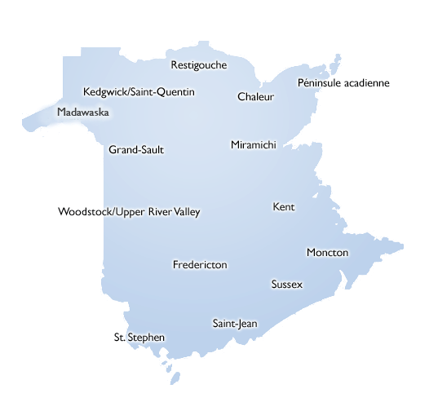
- Role and responsibilities of regional committees

- Ensure the continuity of the Link Program in the host region.
- Get approval from the school district and school principals.
- Serve as a link between the regional committee and the schools.
- Prepare an implementation plan.
- Promote the program (to the community, media, partners, etc.).
- Recruit a coordinator for each school where the program is being implemented.
- Assemble all of the material needed to promote the program.
- Adapt the content of the Link card to their respective regions.
- Develop a Helping Tree and update it at least every two years.
- Open a bank account and manage the regional budget (annual grant from the Department of Social Development for the purchase of promotional material and tools).
- Support the chair of the regional committee in his or her functions.

Regional committee lead
As was mentioned previously, the Link Program has 14 regional committees spread across the province (see map on page 16). To facilitate the program’s implementation and smooth operation, the host region must identify a key person to coordinate program activities.
Table 3: Role and Responsibilities of Regional Committee Presidents

- Make sure the regional committee fulfills its mandate.
- Submit an annual regional report.
- Attend the annual meeting of the provincial committee.

5.3 Preparation of Link material
As was mentioned previously in the section on material, you need to manage the promotional material (Helping Tree, student card, companions’ stickers, posters and banners) for the implementation sites. The inventory of material required for each setting must be determined and surplus amounts predicted. You also need to keep this material up to date. This step includes graphic design, printing, and distribution.

5.4 Promotion of program in host setting
Once the project has been approved, it must be promoted. As was mentioned in the section on conditions for success, promotional efforts must focus first on the leaders in the host settings being targeted. Without their approval, it will be impossible to implement the program in that setting. Promotion can then be done in the host setting with the support of the team/school.

5.5 Training of future companions
Providing the companions with training is a very important component of the implementation process for the Link Program. Training mitigates and limits the risks that the involvement of a large number of people could have. The more people that are involved, the clearer the information that must be provided and the better it must be understood in order to prevent misinterpretation. In addition, training increases feelings of confidence and makes it possible to better manage the procedure and the associated duties and become familiar with the steps to be followed during contacts with users. A thorough grasp of a subject ensures actions that are consistent with what is being requested. Training enables all companions to use the same language and be on the same page. One of the conditions for ensuring the success of the program is therefore for the companions to have at least some training on their role and how to use the Helping Tree. A lesson plan on the training of companions is included as an Appendix, however, each regional committee has to determine the final content of the training, identify trainers, and set a training schedule.
Companion training has four specific objectives:
1- Be familiar with the Link Program.
2- Understand the role of companions.
3- Understand the basic rules of being a companion.
4- Know how to use the Helping Tree.
One thing often raised during training sessions concerns subsection 30(1) of the Family Services Act, which states as follows:
30(1) Any person who has information causing him to suspect that a child has been abandoned, deserted, physically or emotionally neglected, physically or sexually ill-treated, including sexual exploitation through child pornography or otherwise abused shall inform the Minister of the situation without delay.
This Act applies to all young people under the age of 19. Training teaches companions that, if a young person is being abused or neglected, the situation must automatically be reported to the Department of Social Development. This is not a special rule that applies only to companions; it applies to every citizen. If necessary, more information about this legislation can be found on the website http://laws.gnb.ca/en/BrowseTitle

Another important consideration is parental consent. If a young person under the age of 16 decides to consult a professional service, parental consent may be required before the service can be accessed. However, no consent is required to provide information as a Link companion.
Please refer to Appendix 1 (Lesson plan - Training for Companions) for more suggestions on this topic.

5.6 Launch of the program in the host setting
It is important to plan student awareness efforts thoroughly. Each Link team decides and organizes the launch of the program in its setting. Planning requires team work that involves the administration, the coordinator, and the companions. Examples of awareness and launch activities are listed in section 5.13.

5.7 Ensuring implementation of the Link program in the target setting
First, it must be ensured someone is in charge of each of the tasks required for successful implementation. The various actions are carried out with the help of the implementation guide and all of the resources available to the committee.

5.8 Getting the approval of school principals
Without managerial approval, successful implementation is in jeopardy. As was mentioned in the section on conditions for success, they are the ones who make staff available for implementation and provide the support needed to set up the program.

5.9 Construction of Helping Tree
A set of issues has already been identified by the Link Program. Look at one issue at a time, and for each, identify all of the resources, services, and organizations that can offer assistance in a column above the issue. The order the resources are in is not important. The tree is not read from bottom to top. The person going through a difficult time has the last word about the resource he or she wants to meet with. A teen who has already received services from an organization but was dissatisfied or had a conflict with a service provider might want to consult another organization.
If necessary, do the same exercise for the second issue, again according to the services available. A resource may be identified for more than one issue.

5.10 Validation of partner organizations
After all of the resources, services, and organizations that can provide assistance according to the type of issue have been identified, they must be validated. Simply put, you must check that all the information is correct. That information could be used to prepare a glossary.
The process of validating the information in the Helping Tree is very important. If the intention is to have a tool with information that is correct, up to date, appropriate, and functional, you must check the information carefully.

5.11 Host setting awareness
Now that the collaborative and partnership efforts for implementing the Link Program have been established, you must promote the program and raise local awareness.
The first step is to invite the school, if it is not already a member of the local committee, to a presentation on the Link Program to create awareness of the positive impact the program could have on the clientele. The response of the various schools and the position of the local school district will make it easier for the committee to prepare an implementation schedule. The principals will have to present the program to their staff and board of trustees. A representative from the regional Link committee may need to be there to help the principal with the presentation. Awareness is key to rallying people around the program, promoting it, and providing support for youth.
The more people there are who are aware of the program, therefore of the opportunity for improving access to services for local youth, the greater are the chances of success and the greater the impact will be.

5.12 Printing of promotional material
At this stage, the number of implementation sites must be determined. Knowing the number of sites makes it possible to know the number of companions and the number of individuals that frequent the sites. Using this information, you can determine the required number of copies for each tool.
The material is not universal since it contains information about the resources available in each region. The graphic design of certain tools will therefore need to be revised before it is sent for printing. The draft provided by the printer must then be validated. When all of the checks have been done and the tools seem to be free of errors, final approval is given.

5.13 Launch of the program in schools
Before the school launch, at least three steps must have been completed:
  - Recruitment of companions
  - Provision of basic training for the companions
  - Having the material required and being ready to distribute it.
It is then up to each school, in collaboration with the coordinator, to decide how to raise awareness among students and when the Link cards will be distributed. Some group activities will have a significant impact on the students’ interest in the program. These include showing of the video explaining the program, a representative object (yellow sweater) for everyone involved in the program, and simultaneous distribution of the Link cards. A special activity for the first day of school could introduce the Link Program by giving a Link card to each student and introducing the companions.
The launch does not need to be long and complicated. It is the impact of the moment that enables students to engage in the program and understand that the administration opted to put in place a serious structure to help them. Examples of activities include a human chain, a photo of all the students gathered together, or even a ribbon-cutting ceremony as a kick-off at the school.
After the first year of testing, the site may decide to include the Link Program in its code of conduct. At the start of year 2, it could redistribute the Link cards to ensure that new students have a card and that those who lost theirs receive a new one. The ongoing promotion of the program at the school helps the students remember that companions are there, and it encourages them to turn to a companion if they need someone to listen to them.

Table 6 provides examples of launch activities held at New Brunswick schools.

Table 6: Examples of Launch Activities

Description
- Presentation of the video to all groups.
- Discussion with the students.
- Presentation of the video to all groups during Provincial Suicide Prevention Week. Assembly for all students in the school’s gymnasium. They are placed in a spiral formation, and the companions are asked to tie a knot using two yellow ribbons to strengthen the chain. Each student holds one end of a yellow piece of wool in his/her hand. They then take the other end from their neighbor. When they raise their arms, there is a chain linking all the students together.
- Link booth during parents’ meetings.
- One school gave the companions’ email addresses to students who wanted to use the Internet to ask for help.
- Promotion of the program in the student guide.
- Yellow sweatshirt worn by the companions one day a week for a month.
- Community TV spots (messages) with information about the Link Program.
- Large poster with the companions’ photos and names to make them easier to identify.

5.14 Public launch

The launch of the Link Program should be brought to the attention of as many people as possible if only to highlight the work of the partners involved. One possible option is to hold a news conference. The following steps can help ensure the success of such an event:
- Set a date.
- Identify the people (dignitaries) to be invited, e.g., local MLA, mayor, administrators of the institutions involved, representatives of financial partners.
- Design the invitation that will be sent to the members of the regional committee and their executive.
- Invite the administrators of the institutions where the program will be implemented.
- Decide whether to invite people from the schools involved, such as companions and coordinators.
- Determine where the conference will be held according to the anticipated number of invitations.
- Plan the welcome.
- Plan the material for the presentation, the material to be handed out, etc.

Calling upon a person who is responsible for communications at one of the organizations represented on the local committee is a good way to ensure a successful news conference. The number of invitations may seem large, but it is one way of showcasing everyone who participated in this major project. Everyone will be contributing time and energy, and it is a good idea to recognize this.

Conclusion – Part 5
Each local committee will decide how it will organize the various steps. It should be kept in mind that the subcommittees are all interconnected and that the focus should be on effective communication.

Part 6: Implementation

We should now look at the possible pace of implementation in order to get a better idea of opportunities. As was mentioned earlier, the Link Program was initially implemented for and by a single school. Other schools then expressed an interest in the program. The program gradually spread across the Grand Falls area. Other parts of New Brunswick then joined the long Link chain, and today the program is offered throughout the province. It is essential to take into account and adjust for the different circumstances and values in each region or community and the availability of resources. The same applies to schools. It is therefore up to each regional committee to identify the implementation process that best meets needs and circumstances.

6.1 Coordinator/ /Companion
As mentioned previously, a program coordinator is required in each implementation site. The school principal may want to be involved in the process of identifying a coordinator. Companions are recruited by the principal and/or the coordinator, who are responsible for inviting interested persons to become Link companions. This truly is an invitation because companions must be volunteers. Once again, it is important to clarify the role of companions: they aren’t specialists; they just support young people in their efforts. They respond to very specific requests for help and offer support to ensure that each young person is referred to the right resource.

Part 7: Conditions for Success

To determine whether a program has been successfully implemented, you must identify and take into account the characteristics of the setting in question.
When a co-worker or manager presents the program at a team meeting, the heads of the institution and the stakeholders generally want to know and analyze the pros and cons of the program before it is adopted. In addition, they want assurance that the program meets the needs of the clientele adequately and effectively. These concerns will likely be mentioned to the person who suggests implementing the Link Program. In order to have as much information and supporting evidence on hand as possible, the following should be considered.

7.1 Aspects relating to the persons implementing the program
7.1.1 Positive impact on the organization as a whole
All levels of the school organization are affected by and benefit from the program: students, teachers, administrators, support staff, and even parents. The Link Program connects all of these people, mainly because of its simplicity and ability to mobilize people. Also, the Link Program can be applied in all school contexts, including transitions between courses, lunch hours, and class time.
7.1.2 Simple structure
The Link Program has a simple structure with a clear goal: offering support to young people going through a difficult time who ask for help. The program’s clarity and simplicity, combined with the links between the program and the orientation of the site, broaden the scope of the program, while reducing start-up difficulties. A well-articulated program is more user friendly, whereas accessing a program that has a complicated structure requires more time and support. The type of support provided by the Link Program in no way changes the approaches used by informal caregivers in the community. It adds value to the support available with a clear, easy-to-use referral tool. The Link Program does not require any changes to the habits of the companions involved, since many of them already listen to young people as part of their duties.

7.1.3 Involving the right people (regional committee)

When a regional committee is being set up, it is important that those involved believe in the project. The partners represented on the regional committee must be convinced of the program’s benefits.

7.1.4 Getting the support of the partners’ executive directors
To ensure the effectiveness of the regional implementation committee, the support of the executive directors of the partners wishing to help implement the Link Program must be obtained.
The leaders should be asked their position on the project. They must be asked to describe the limitations and the assets they perceive in relation to the implementation of the program. This discussion will bring to light the components of the program that will require some adjustment in order to reflect local circumstances. The leaders’ official position will help to mobilize people.

7.1.5 Using a collaborative structure
Having a collaborative structure in a given region greatly facilitates the implementation process. It makes it easier to promote and put the program in place. It also makes it possible to connect with a greater number of stakeholders working on behalf of young people. This, in turn, increases the chances of other actors becoming involved in the implementation process.

7.1.6 Validating the organizations included in the Helping Tree
The organizations included in the Helping Tree should be validated. By contacting all the organizations in the Helping Tree, you can check their contact information, as well as give them an official place in the Helping Tree in relation to each issue. This will help create a sense of ownership of the program within the community and among the local organizations providing services.

7.2 School-related Aspects (host environment)

7.2.1 Getting the support of the school district superintendents
Since the goal is to reach as many young people as possible, it is obviously important to have the school districts on board. Having the support of the school district superintendent ensures that the implementation committee has access to all of the schools. The local committee will be able to decide on the strategy to be used to obtain the approval of the superintendent and the person responsible for educational resources, who may turn out to be a major collaborator in the implementation process.

7.2.2 Mobilizing the administration
The mobilization and leadership of assistants and coordinators and the strong support and mobilization of school principals are important conditions for success as well.
Mobilizing the manager of the implementation site will help in freeing up the principal actors involved in the program (for meetings, training, and awareness planning). Also, the manager’s support will lend much-needed credibility to the program.
Before the organizations are approached, it might be worthwhile for the implementation committee to identify the person who holds the functional power within the organization (host setting) where you hope to implement the program. This person manages the resources, which can be financial but are mainly human (companions + stakeholders), required to launch the program. It is therefore important to discuss the project with this person.

7.2.3 Promoting the voluntary involvement of companions
The aim here is to promote the optimum participation of the actors involved. People will feel free to invest in the program at their institution and will do so because they want to, not because they feel obligated to.

7.2.4 Informing all stakeholders (parents, unions, boards, etc.)
Because companions are volunteers, it might be a good idea to inform the unions about the program so they will be able to see what a companion does. To prevent parents from becoming concerned and to encourage them to show their children that they support the project, they must be given clear, understandable information.

7.2.5 Motivating the team
As with any project or initiative involving change, the first indicator of probable success is how motivated people are about the proposed project. You must be able to identify the level of motivation of the partners and the leaders in the host settings. A good indicator of motivation is the involvement and availability of human resources to work on the implementation process.
It is important that the managers of health and educational institutions and community organizations agree to free up some human resources to work on the program. To keep the parties motivated, meetings must be well structured, with the ultimate goal of limiting meetings.

7.2.6 Providing training
Basic training instills a feeling of control and confidence in the program. It also provides a shared update, which allows for consistent implementation and application of the program. It enables the companions to anticipate and plan for what comes next, reduces anxiety, increases understanding of the program, and enhances the ability to use the Helping Tree.
The training is of short duration. The fact that the program does not require companions to be specialists means that they just have to learn how the program works. The training does not include any complicated theory. The Link Program makes use of informal caregivers and therefore does not focus on a “professional” helping relationship.

Conclusion

All of those involved in the Link Program are certain of one thing: the program is a simple and extremely effective way of helping young people who are suffering in silence and are unable to, or do not know how to, ask for help.

We all want people who are going through a difficult time to regain control of their lives, but it seems increasingly obvious that a support process is the key to gaining access to the appropriate resources.

Directing young people towards the right resource will enable them to get the help they need and to feel important and supported.

THANK YOU FOR BEING PART OF THE CHAIN!
Appendix 1

Training for Companions

This information is meant to be a guide to the training provided for future companions. The training should not last longer than 90 minutes. To support them in their role, some companions may want to take safeTalk training. For more information about this training, please contact your regional suicide prevention committee. You can also learn more by consulting http://livingworks.net/page/safeTALK.

Training Overview

  - General introduction to the program
  - Video – The Link Program
  - Your availability
  - Welcome
  - Confidentiality and mandatory reporting
  - Consent
  - Active listening
  - Using your own judgment
  - Follow-up
  - Conclusion

==================================================================

  - General introduction to the program

Talk about the program's history, goal, and objectives, how it works, and the role of companions.

- Video – The Link – A Life Experience

Watch the video The Link – A Life Experience. You can watch this video by visiting the program’s web page at http://programmelemaillon.com/intro.php.

- Your availability

- Meet with students only when you are available and you feel comfortable doing so. If you are not ready, postpone the meeting.
- If you are not immediately available, let the student know that you can’t meet with him or her right away and explain that you would like to meet at a later date when you can give him or her your full attention. Confirm a meeting time.

- Welcome

  - Give the card back to the student or give him or her a card if he or she does not already have one.
  - Be natural and stay calm.
  - Adopt a warm, emphatic approach.
  - Take the individual seriously.

- Confidentiality and mandatory reporting

  - If the student asks about confidentiality, don’t make promises you can’t keep. You must let the student know that you are bound by certain laws to disclose information when someone’s life is in danger or in situations of abuse or neglect.
  - Mandatory reporting: Companions, like any other citizen, are required to report cases of abuse or neglect involving children under the age of 19 to the Department of Social Development.

- Consent

  - Companions don’t need parental consent to direct a young person to a resource or service. However, certain resources or services may require parental consent.
  - Companions are not responsible for requiring parental consent to access resources or services.

- Active listening

  - Definition: The ability to listen to and empathize with a person in need in order to strengthen the bond with that person.
  - Hearing is a natural involuntary process similar to breathing and digesting; listening is a cognitive voluntary process. Listening is understanding.
  - Respect the individual’s privacy.
  - Don’t forget to take the individual seriously.

To apply active listening, two techniques are generally used:
- Validation
- Empathy.

Validation involves rephrasing in our own words what we have understood, sharing it with the other person, and having it confirmed. We can therefore continue on, knowing that there is mutual understanding. The more understood the person feels, the more he or she will feel comfortable continuing to share his or her concerns. The bond of trust will be strengthened.

Here are a few turns of phrases you may find useful:
  - If I understand correctly, you’re telling me that… Is that right?
  - To sum up, you’re telling me that… Is that right?

- Empathy

Empathy means showing the other person that you understand how he or she is feeling emotionally, using the following expressions:
- I understand that what you’re feeling may be causing you pain…
- I understand you when you tell me that…

During the meeting, avoid the following:
  - Selective listening
  - Interpreting the words
  - Listening in order to provide an answer
  - Approving or accepting

*Listening is understanding the other person’s message and intentions.

- Use your judgment (Helping Tree)

  - Before making a referral, and whenever possible and appropriate, encourage students to talk to their parents about their issues.
  - Don’t fall back on the Helping Tree too quickly, even though the resources aren’t listed in any particular order. Use your judgment (e.g., a student experimenting with drugs for the first time - avoid making a referral to the Addiction Centre).

- Follow-up

  - Follow-up is designed to ensure that students act on the agreed-up approach.
  - It must be scheduled to take place within an appropriate time frame

- Conclusion

  - Remember that you are a link in the chain and that your role is to help young people who are experiencing issues access services that are available in the community. By making it easier for them to access resources, you will help them solve their issues before they get worse and lead to more serious situations.

Questions?

